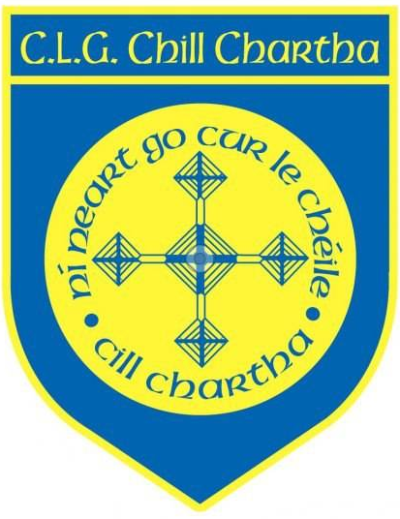
C.L.G. CHILL CHARTHA

AGM NOMINATIONS 2021

Patrons: Fr Eddie Gallagher, Bishop McGuckian

- President _________________________________
- Chairperson _________________________________
- Vice Chairperson _________________________________
- Secretary _________________________________
- Assistant Secretary _________________________________
- Treasurer _________________________________
- Assistant Treasurer _________________________________
- Field Chairperson _________________________________
- Minor Board Chairperson _________________________________
- Coaching Officer _________________________________
- Registrar _________________________________
- Children’s Officer (Elected by outgoing Club Executive)
- Healthy Club Officer _________________________________
- PRO _________________________________
- Oifigeach na Gaelige (Elected by outgoing Club Executive)
- Senior Team Manager _________________________________
- Reserve Team Manager _________________________________
- U20 – Team Manager _________________________________
- Players Representative _________________________________
- Ladies Board Chairperson _________________________________
- Executive Committee Member _________________________________
22. Development Officer _________________________________
23. Delegates to County Committee
i)____________________________ ii) ________________________________

------------------------------------------------------------------------------------------------------------------------------------
Submitted by:

Members Name: _______________________ Members Signature: ________________________

